**INSTRUCTION**

1. Modifier Code

Open vscode goto src -> resources -> views -> partials -> header.hbs

Find the line “[Fill Your Name Here]” delete it and change it to your name “Ex: Trieu”

If you want to change the header color you need goto the bootstrap 5 site and find the color class then change it

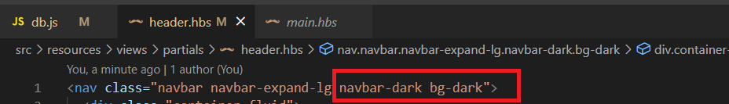

1. Create Repository in GitHub

Click new

Fill your repository name “Example: atn-store-1” and choose private repository then click create repository

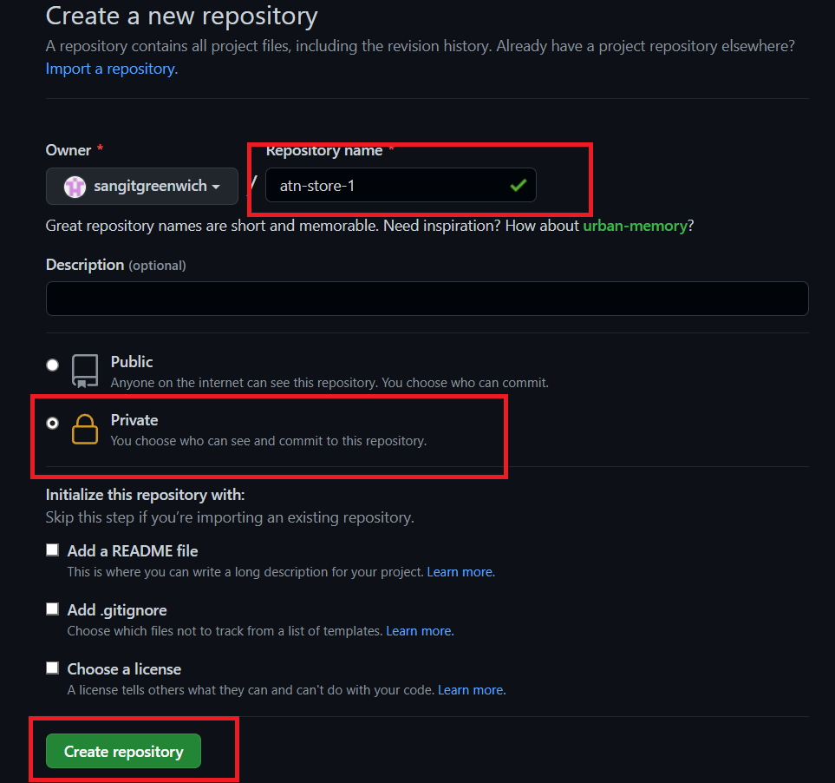

After that you need to keep these information to support for the next step **This is example do not using**

1. Download & Install Tools
   1. PostgreSQL (pgAdmin)

Choose the version that appropriate with your OS and Download: [pgAdmin4 || Install](https://www.postgresql.org/ftp/pgadmin/pgadmin4/v6.1/windows/)

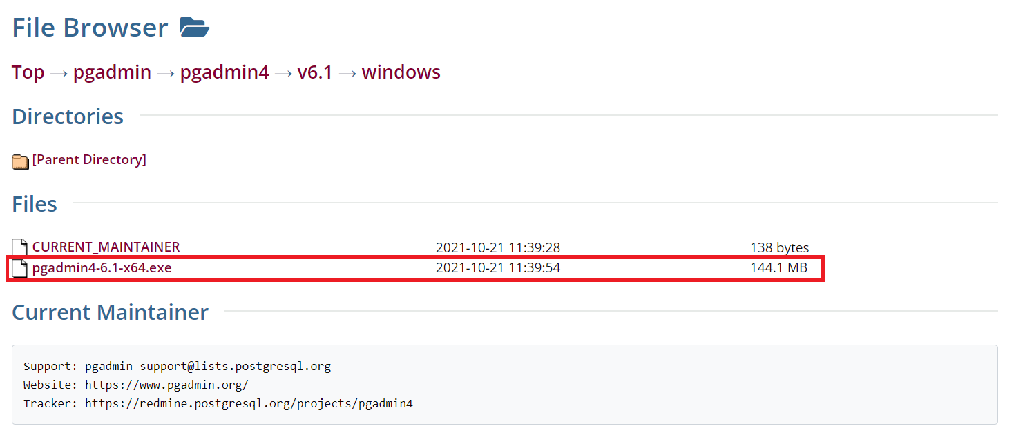

Select this

Open PgAdmin and Set your Master Password

* 1. Install GitHub into your Vscode

Install [Git-scm](https://git-scm.com/downloads)

Set Vscode as a default editor for git-scm

Open Terminal in Vscode then go into the directory containing the ATN file then choose git bash terminal

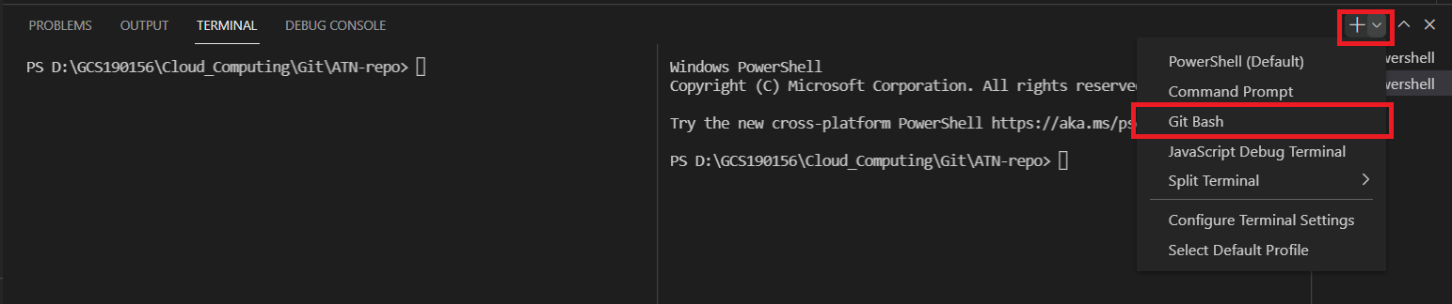

Put the command git init and execute in the git bash terminal to install GitHub lib and repository.



Then execute command git add . to add all the file into the local storage



Execute command git status to check if the file is already charge or not:



Next, Execute command git commit -m “your text description for the file, Example: ATN STORE CLOUD WEB APP v1” to commit file and ready to push file into github



Next, you need to go to your GitHub account and create new repository. After create you will able to see some command, in this step we get the git remote add command to set the repository control the file and ready to push. **This is example repository, do not using**

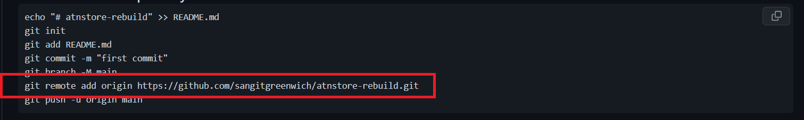

Execute your git remote add… command above in git bash terminal. **Note: you must using your repository.**



Finally to upload or push the local storage file into GitHub server you need to execute command git push -u origin master



Allow the pop-up

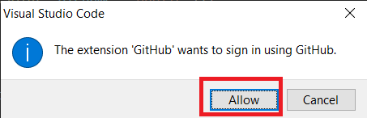

Authorize Vscode to access GitHub Account, click continue and login into your Git account

Click Authorize github

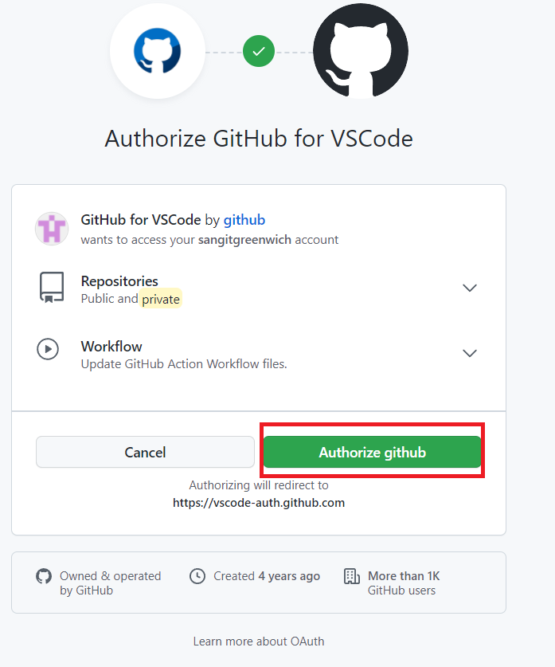

Click Open

It’ll show the line in the top of the Vscode, you need to press enter to confirm.

If the first time you have this message you need to using git push -u origin master again.



Success push

You’ll see all the file you push inside GitHub

Git Ignore node_module to meet the requirement to build server in the heroku platform.

The first step you need to create .gitignore file inside your src directory and put node_modules inside that file

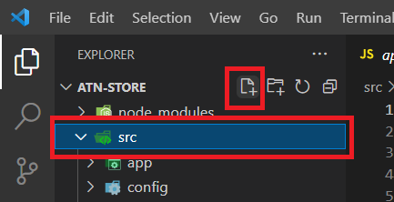

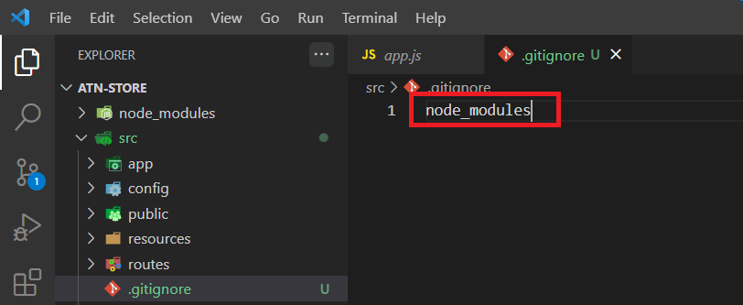

After you do this you need to execute again to push the file, in the git bash terminal follow the step: git status, git add . , git commit -m “Add Git Ignore” , git push







1. Create server on Heroku

Login to your heroku account then Create new app and you need to named the app “Example: atnstore-toys”

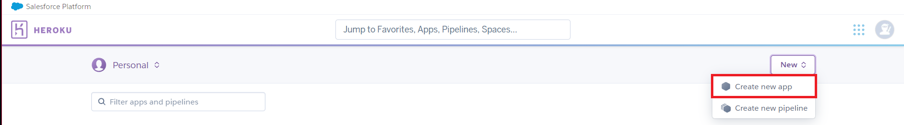

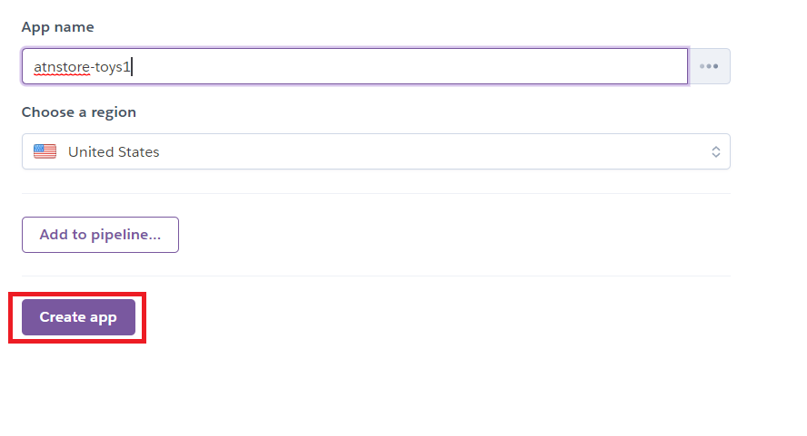

Click the app to config

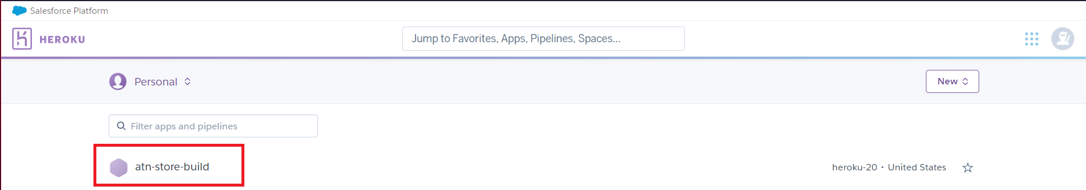

Choose settings tab



Scroll down and click add build-pack

Click the nodejs package then click save changes

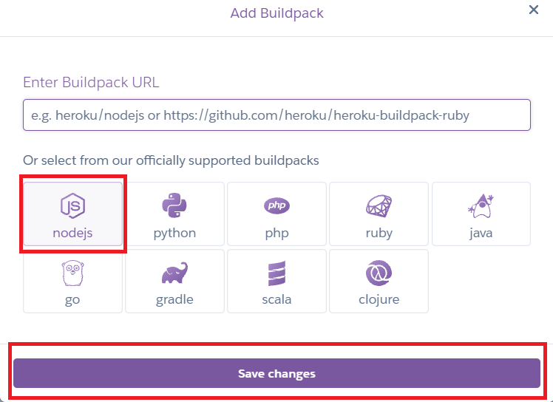

Go back to deploy tab



Select GitHub as a default deploy method

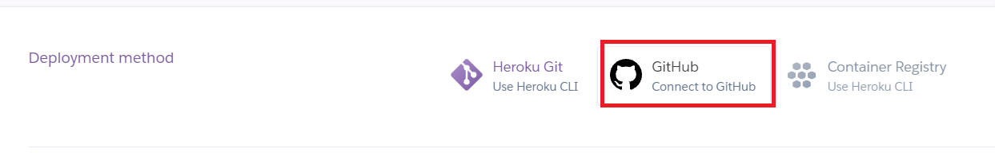

Find your repository name and search in the heroku platform then connect to that repository

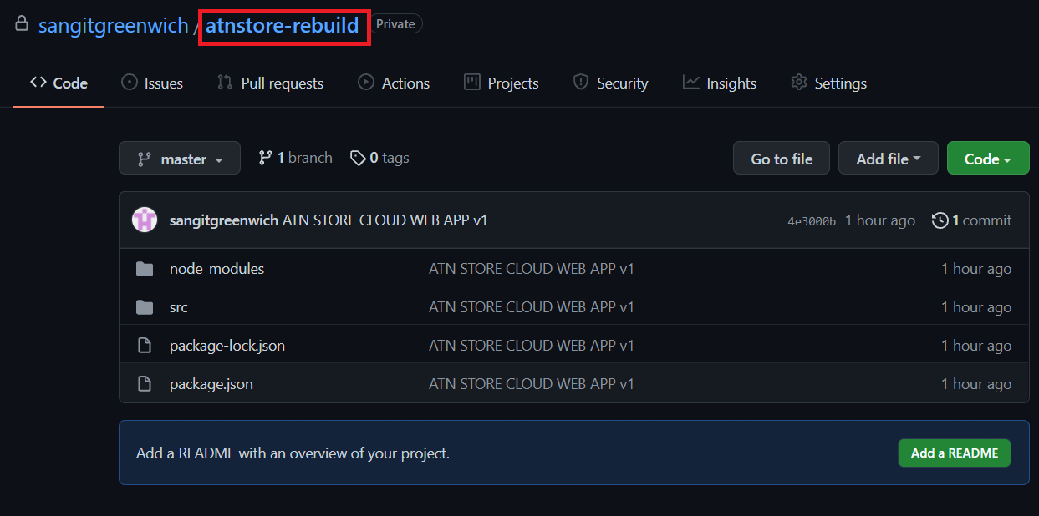

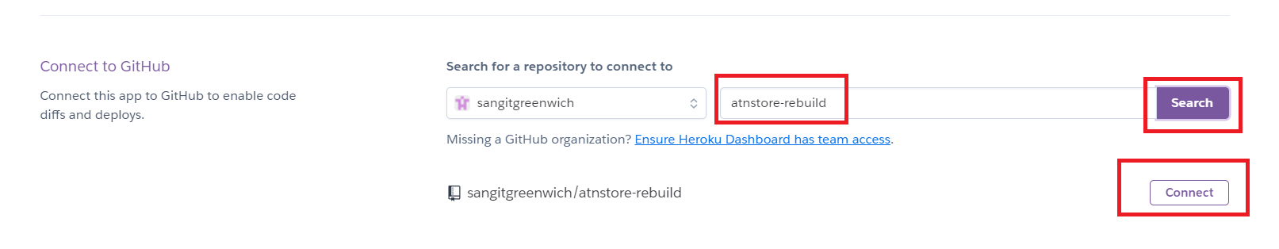

Scroll down and click enable automatic Deploys

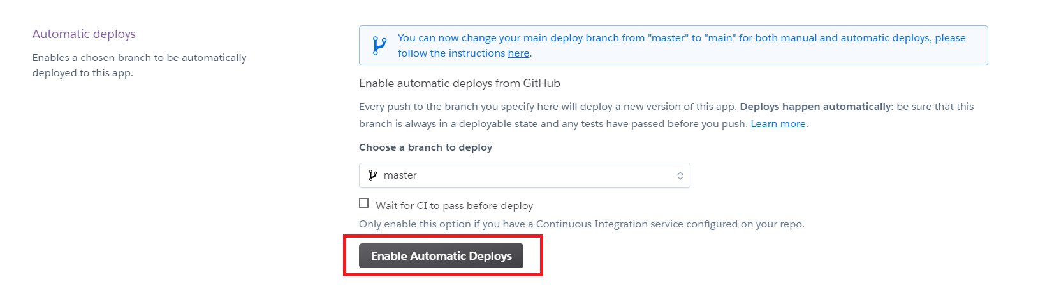

**GUIDE TO CONFIGURE HEROKU POSTGRE SQL SERVICE**

**& PGADMIN TOOL FOR DB MANIPULATION**

1. Download PgAdmin tool <https://www.pgadmin.org/download/>, and run it

1. Create server (**default password 123**)
2. Graphical user interface, application, Word

   Description automatically generated
3. Open Heroku, Tab Resource/Add on/ Find more add-ons
4. Graphical user interface, text, application, email

   Description automatically generated

1. Select Heroku Posgres

1. Install Heroku Posgres

1. Select the app to use the service

Submit Order Form

1. Click Heroku Postgres to open in a new tab

Select Settings tab

Select View Credentials

1. Switch to Pg Admin, fill in the panel with the above credentials information

Advanced tab, DB restriction

1. Open the Databases -> Schemas -> Table and right click the table and select query tool

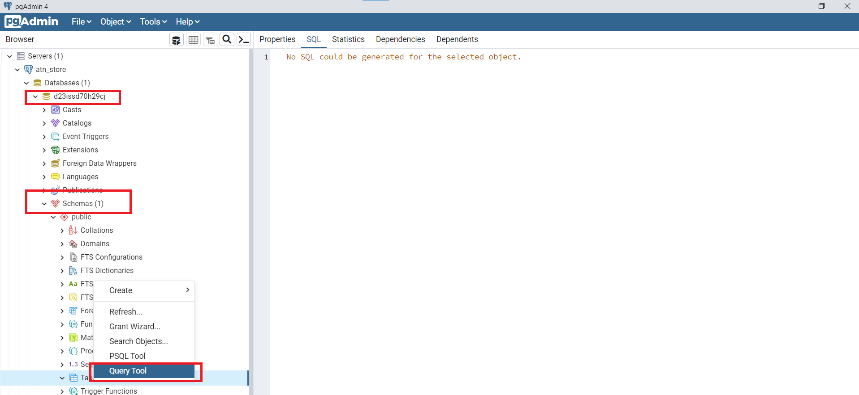

Click the open file button then select your query file the click select

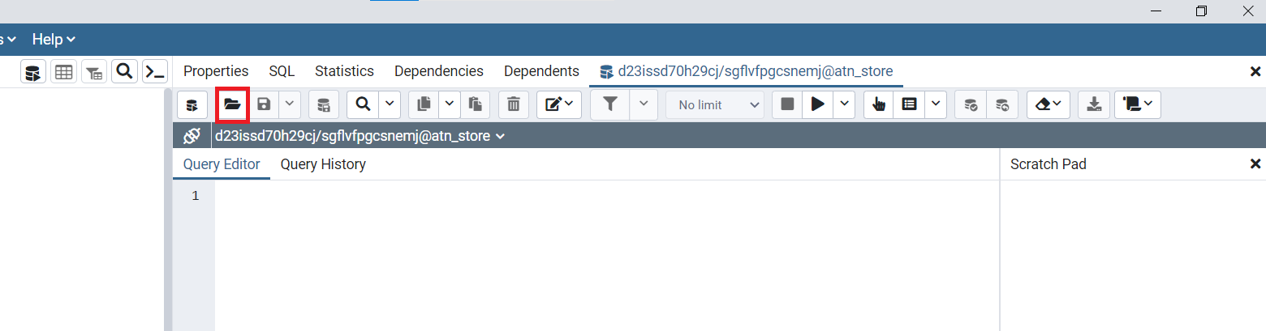

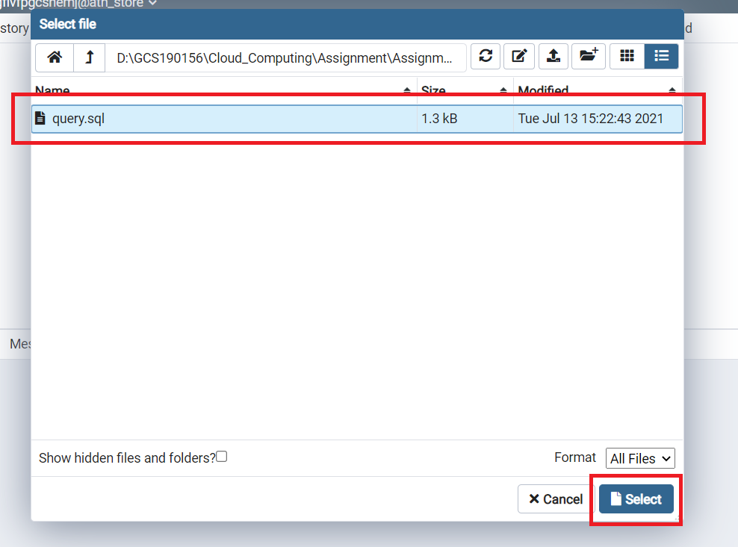

After that you need to run your query by click on the execute button

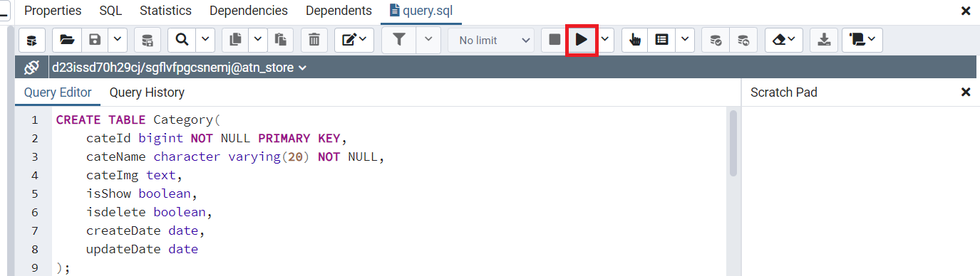

Success

To See all your table you must refresh the database

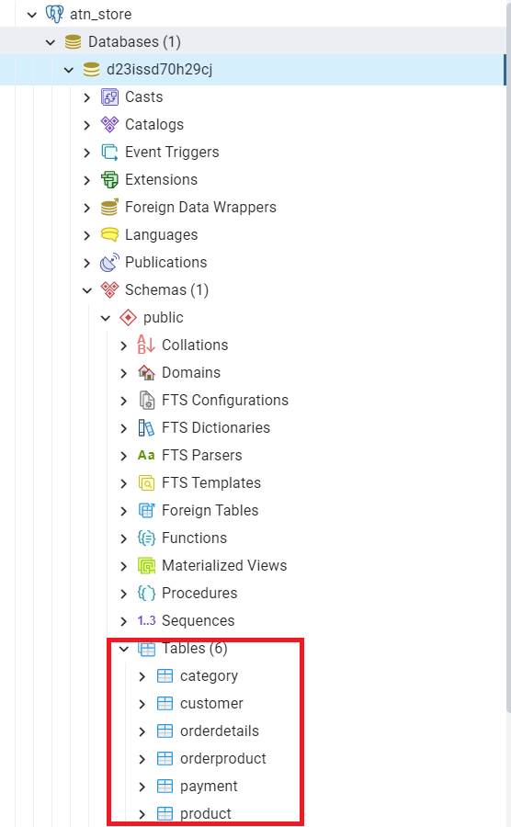

To check and modifier data you must to right click on the table you want then do the step below:

1. Config DB in Vscode

First thing you need to check your database crendentials information then go to Vscode select db.js file inside config folder and fill all the needed information like user, password,…

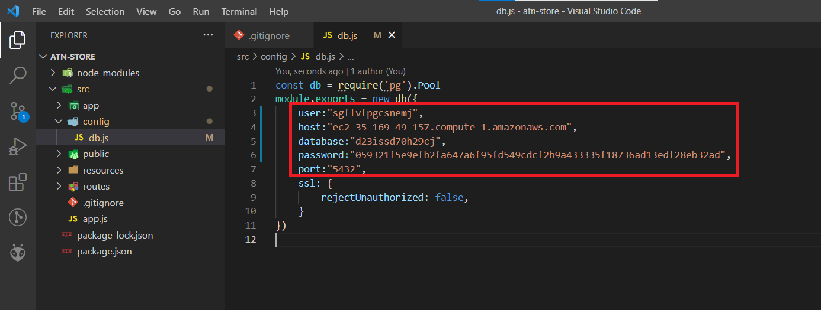

After finished all the step you need to push your data into GitHub again by following step: git status, git add . , git commit -m “Set up Database Connection” , git push









Finally, you need to make sure that all your file is up-to-date

1. Deploy Server on Heroku

To deploy the server on heroku platform you need to select deploy tab then scroll down and click deploy branch



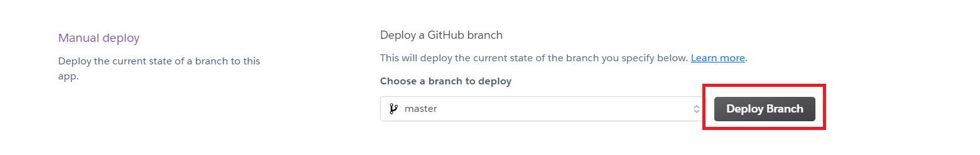

After Finish you can check your website by click the Open app button



You can also see the logs of the website to debug

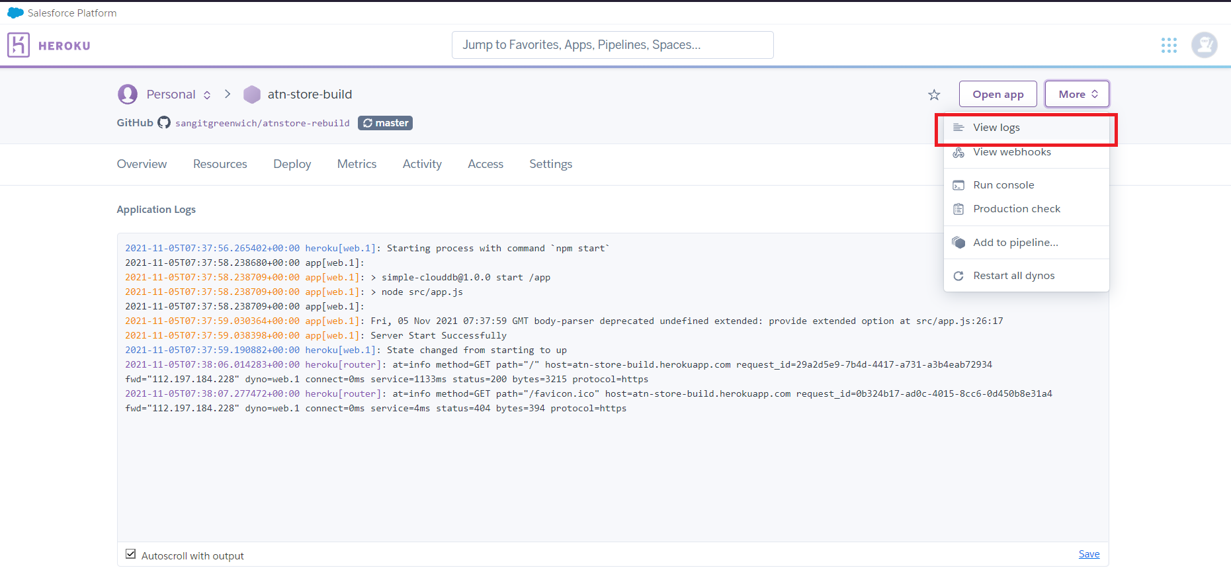

1. Function of ATN
   1. CRUD (Create, Read, Update, Delete) also I have some more like Restore and Soft Delete

Create:

You want to add product, so you need to add the category first, If you have a blank field, your category or product will not add

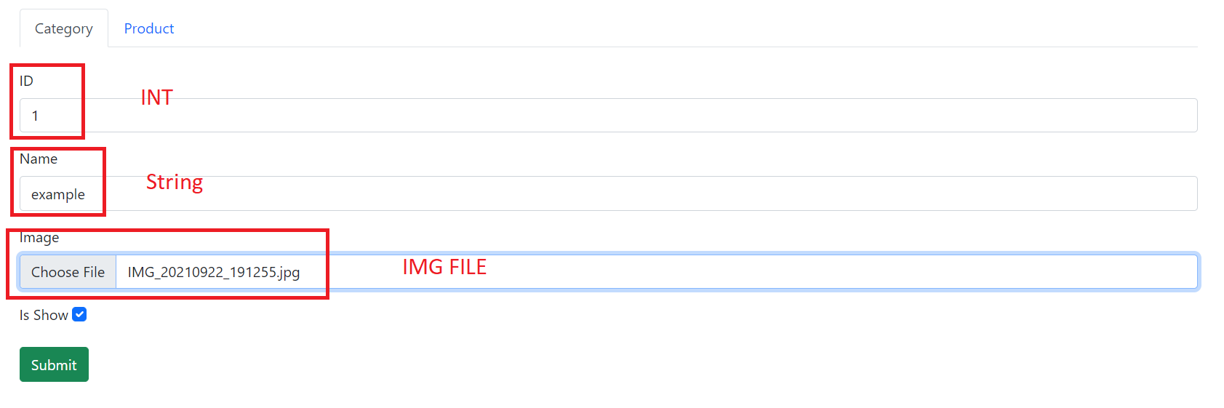

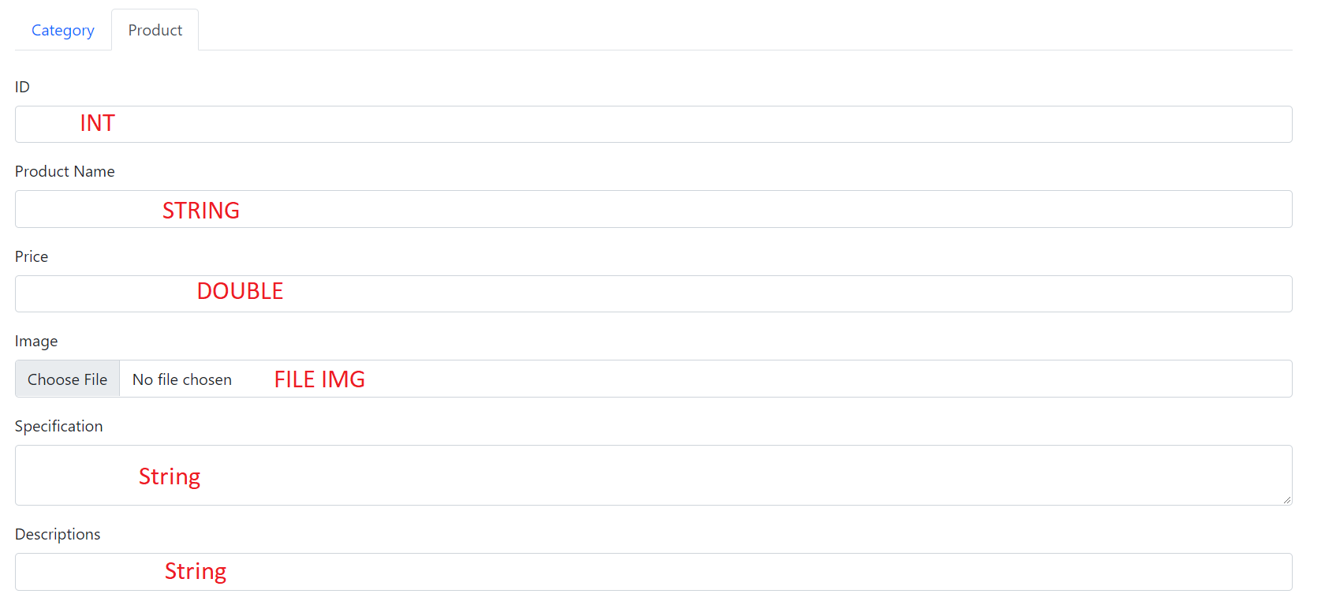

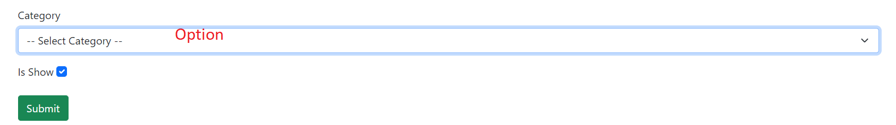

* 1. Detail page, order page, view order – details - invoice

To make the order working you must to go to the pgAdmin and add full customer information

Because we don’t have Register system for the customer. **If you don’t add customer information in the pgAdmin or you input wrong order information your app will crash.**

You need to fill all the information to the customer

Save your data

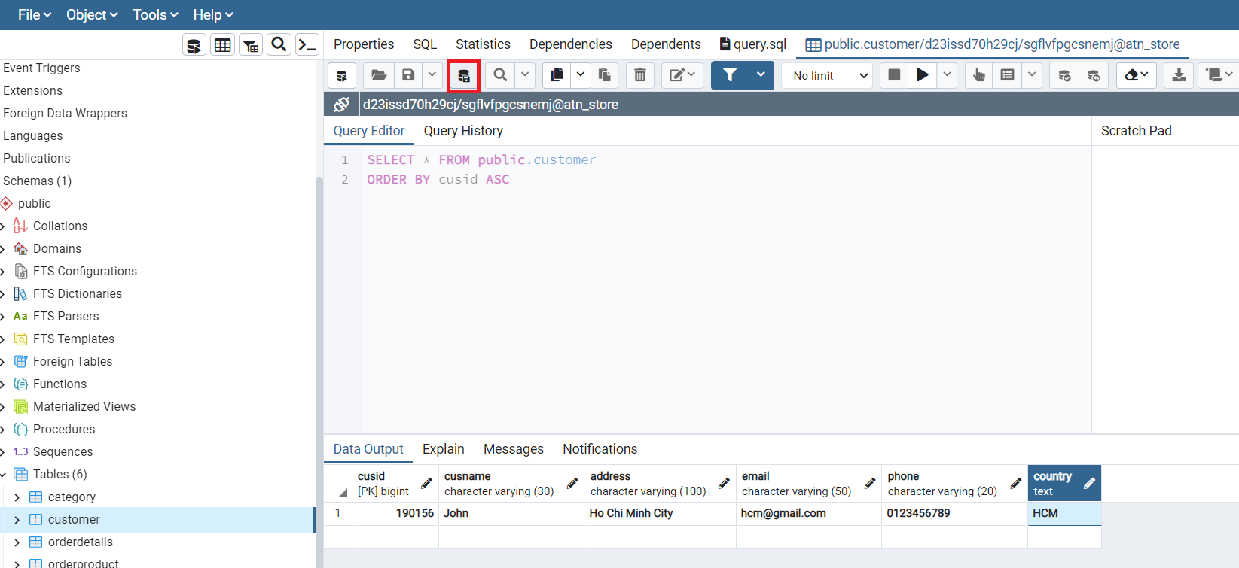

Library Using

Thư viện nodejs: base để start server

Thư viện multer xử lý lưu hình ảnh, và upload

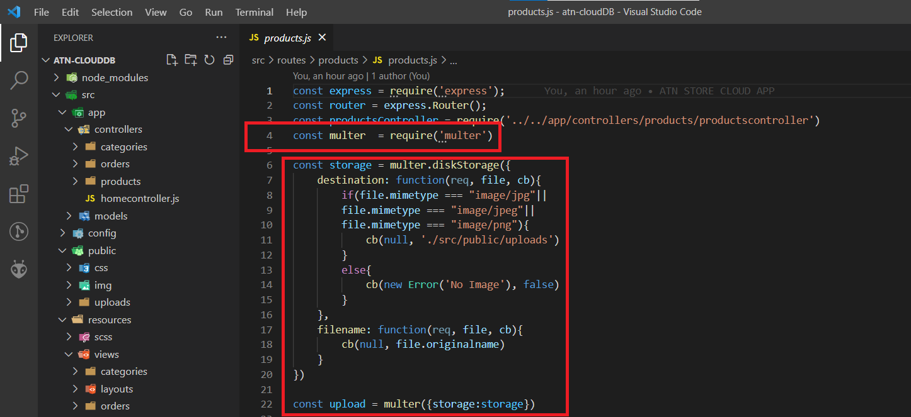

Thư viện express nodejs dung xử lý các tác vụ và static file

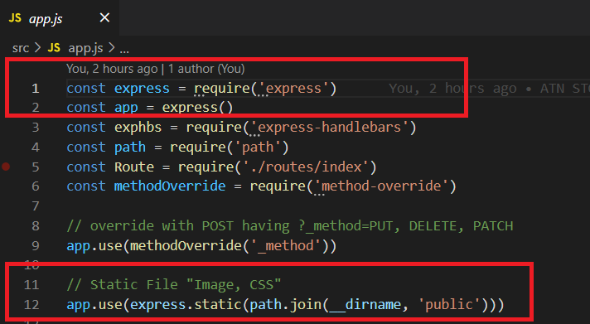

Thư viện npm để start nodejs server

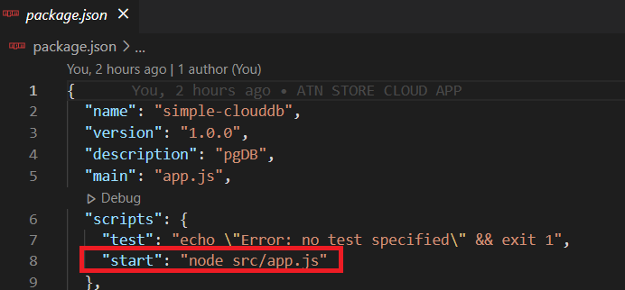

method-override dung để xử lý các form có method là PUT,PATCH,DELETE



Thư viện node-postgres dung để xử lý database

Thư viện express-handlebar chia cây thư mục tổ chức theo mô hình MVC, hỗ trợ viết file HTML bằng đuôi .hbs

